**Project 2 - Helicopter**

Screenshot:

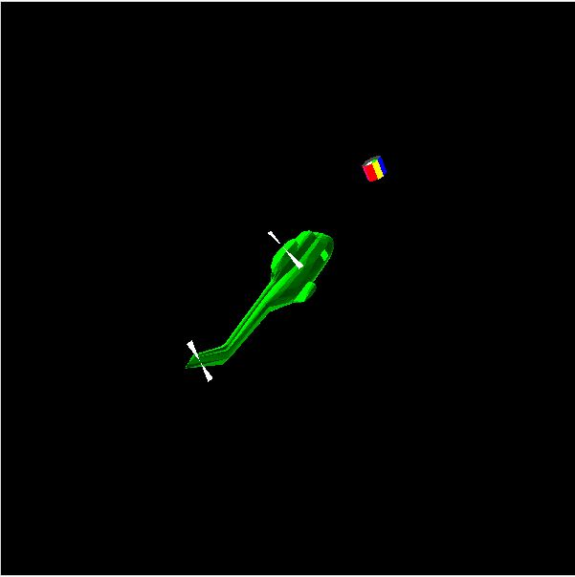

Video Link: <https://media.oregonstate.edu/media/t/0_ae2wrq7g>

Thanks, and have a great day!